Abstract GuidelineS
Stéphane Lambert¹, Franck Bourrier^{1, 2}
¹ Univ. Grenoble Alpes, INRAE, CNRS, IRD, Grenoble INP, IGE, Grenoble, France
² Univ. Grenoble Alpes, Inria, CNRS, Grenoble INP, Institute of Engineering, LJK Grenoble, France

Objectives
Contributors are invited to submit a one-page abstract on the Workshop internet site based on this template. The abstract begins with the submission title and the authors’ names and affiliations. The abstract consists of three main sections. The first one introduces the objectives of the communication (min 10 to max 18 lines long). This section should be concise-to-the-point. As intended to experts, general ideas and comments should be avoided, as well as redundancies with other sections. The two following sections are described below. The abstract may end with two references maximum [1][2] and may include a single figure, image or table, half a page in width (see example below). Affiliations and references should be as short as possible. Compliance with these guidelines (including font size) will be evaluated during the review process in view of formal acceptance. Accepted contributions will be presented orally or as poster. Each participant will be allowed to present only one contribution during Rocexs. Each submission may be complemented with supplementary data (video, additional image or figure…) aimed at the reviewer.

Materials and methods
- This section concerns the material and methods description,
- For study cases, the section title has to be STUDY SITE DESCRIPTION.
- Presented in three or four bullet points,
- Concise and unambiguous
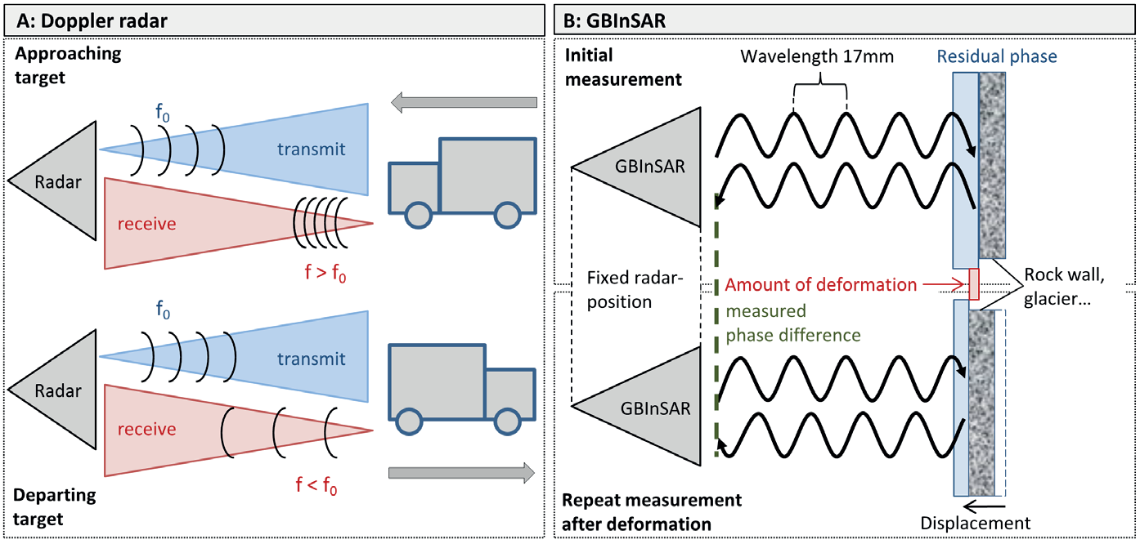
Figure: use a Figure to show essential results. Not mandatory, only if necessary [1]

Main results and conclusions
- This section should highlight the novelty and main conclusions,
- Four or five bullet points,
- May concern the methods employed or the results,
- Suggestion is made to have one take home message
References
[1] L. Meier, M. Jacquemart, B. Blattmann, S. Wyssen, B. Arnold, M. Funk, (2016), Radar-based Warning and Alarm Systems for Alpine Mass Movements. INTERPRAEVENT 2016 Conference Proceedings.
[2] M. Spadar, A. Giacomini, O. Buzzi, JP Hambleton, (2012), Prediction of the bullet effect for rockfall barriers: a scaling approach. Rock Mechanics and Rock Engineering 45, 131-144

